Stephanocyclus meneghinianus (Kützing) Kukikovskiy, Genkal & Kociolek 2022
Previous name used: Cyclotella meneghiniana Kützing 1844
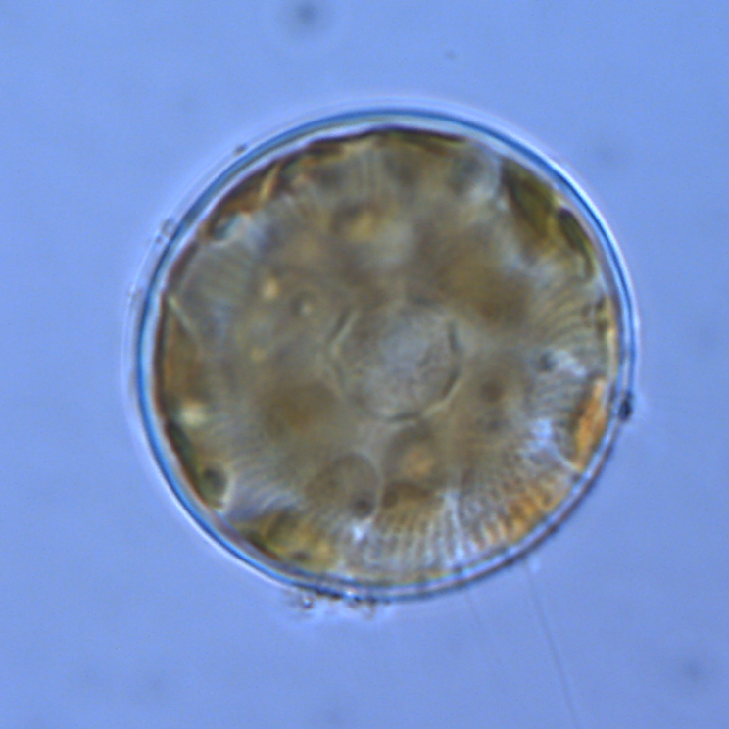
Phylum: Bacillariophyta
Class: Thalassiosirophyceae
Order: Stephanodiscales

Habitat: planktonic
Distinctive features: winter species in Kinneret, requires Si, looks similar in shape to its relative Pantocsekiella (previously Cyclotella) polymorpha but larger in size
Organization: single cells
Color: golden-brown
Cell shape: drum-like, short cylinder
Cell diameter (D): 10 – 28 μm, median: 18 μm (N=481). Cell diameter varies significantly making it necessary to measure it routinely.
Cell length (L): 5-16 μm, median: 9 μm (N=481).
Cell biovolume: 500 – 6000 μm³, median: 2300 μm³.
Biovolume equation: Cylinder, V = L π (D/2)².

Morphological features:
Stephanocyclus meneghinianus is a single-celled centric diatom, having a circular valve. Until recently it was known as Cyclotella meneghiniana. Valve surface is gently undulated (=wavy, i.e. not completely flat), S-shaped when observed in girdle view (Plate 1). Cell shaped like a petri dish (or drum). Valve face with a distinct central region surrounded by radiating areolae (Plate 2) occupying a belt of 4-6 µm around the cell periphery, with 6-10 costae (= elongated, solid thickening of the valve) in 10 µm at margins. The central valve area is smooth. Discoid plastids are arranged around the margin of the cell. The species is typically less abundant than the similarly looking but smaller centric diatom Pantocsekiella polymorpha.
Based on morphometric and molecular methods Beszteri et al. (2005; 2007) claimed that Cyclotella meneghiniana is a group of cryptic taxa.

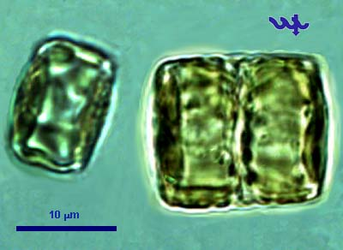
Plate 1. Stephanocyclus meneghinianus seen from the side (girdle view). The S-shape of the valve in girdle view (distinct in the right-most cell) is diagnostic. Usually this species is unicellular, but occasionally after division two cells remain attached, as in the right specimen. Photo by Alla Alster.

Plate 2. Stephanocyclus meneghinianus from valve view. Note stria (=radiating lines) around cell periphery. Photo by Alla Alster.

Ecology:
Stephanocyclus meneghinianus is a common component of the Kinneret winter plankton (Jan-March), mostly reaching maxima of several tens of cells/mL, but on two exceptional occasions in the 1980s it peaked with ~ 1000 cells/mL (Figs. 1, 2).
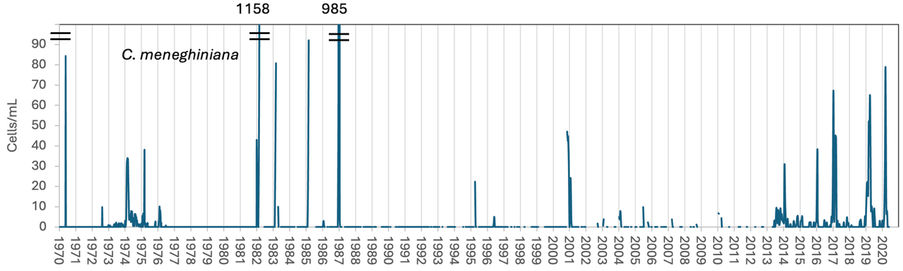
Figure 1. Time series of Stephanocyclus meneghinianus mean epilimnion cell abundance (cells mL⁻¹), Lake Kinneret, 1970-2020.
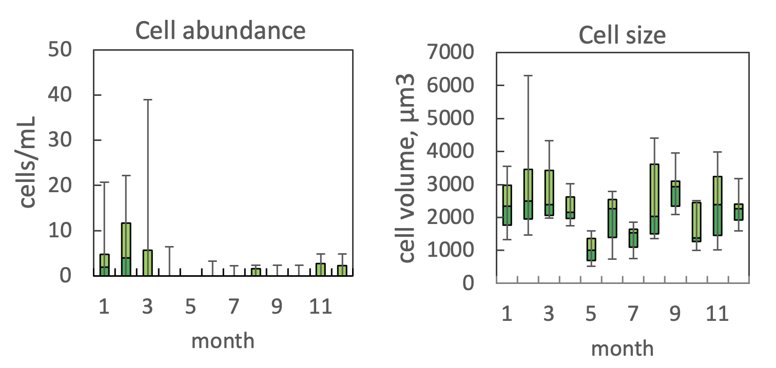
Figure 2. The annual pattern of water column cell abundance (left) and volume per cell (right) of Stephanocyclus meneghinianus, based on data for 2005-2020. Statistics shown are: median – middle line; 25th to 75th percentiles – box content; 90th and 10th percentiles - top and bottom bars, respectively. The high variability in cell size from May to December is partly due to few measurements, as the species is rare during those months.
Physiological features: Like all diatoms, Stephanocyclus meneghinianus requires Si – which is always present in Lake Kinneret at concentrations >4 mg L⁻¹.
Environmental conditions:
Stephanocyclus meneghinianus abundance was independent of water level, euphotic zone depth, pH, and concentrations of chloride, organic N and turbidity within the ranges of values found in Lake Kinneret . Its higher concentratins occured when the lake was fully mixed (z_{mix} >35 m). At that time of the year alkalinity was >130 mg L⁻¹, Calcium >50 mg L⁻¹, water temperature <18.5°C. Abundance inreased with nitrate concentration (Fig. 3).
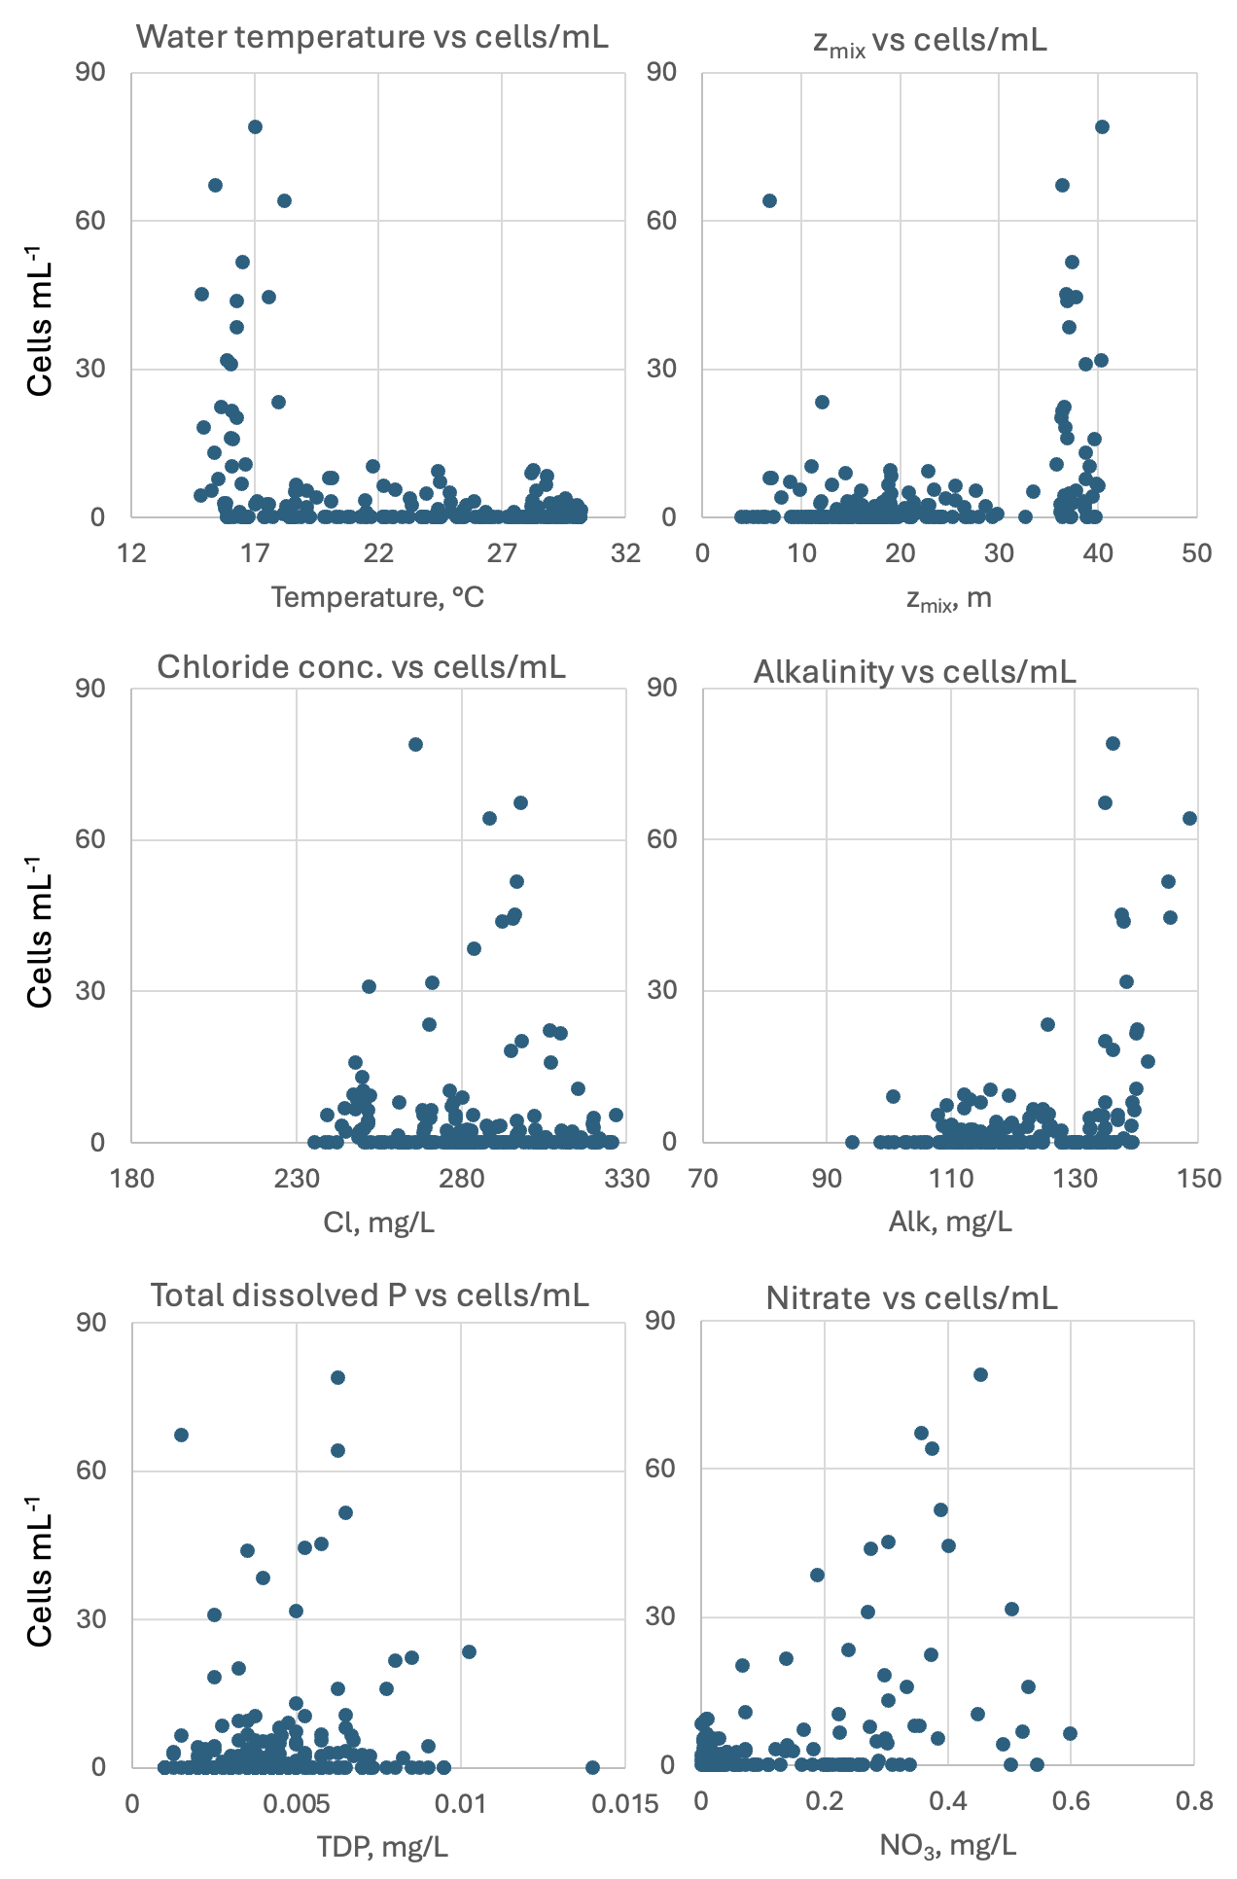
Figure 3. Stephanocyclus meneghinianus abundance (cells mL⁻¹) vs. selected environmental parameters recorded at the site and time of sampling, showing higher cell concentrations when the lake is fully mixed (z_{mix} >35 m), water temperature is low and Ca and alkalinity are high. Abundance increases with nitrate. Based on data for 2012-2020.
Cite this record as:
Tamar Zohary, Alla Alster. [Date when Item was last updated]. Electronic publication. Israel Oceanographic & Limnological Research. [Date when last accessed].
Further reading:
Beszteri B, Ács É, Medlin L. 2005. Conventional and geometric morphometric studies of valve ultrastructural variation in two closely related Cyclotella species (Bacillariophyta). European Journal of Phycology. 40(1):89-103.
Beszteri B, John U, Medlin LK. 2007. An assessment of cryptic genetic diversity within the Cyclotella meneghiniana species complex (Bacillariophyta) based on nuclear and plastid genes, and amplified fragment length polymorphisms. European Journal of Phycology. 42(1):47-60.
Kuznetsova, I., Kapustin, D., Gusev, E., Martynenko, N. & Kociolek, J.P. 2022. Resurrection of the diatom genus Stephanocyclus (Coscinodiscophyceae: Stephanodiscaceae) on the basis of an integrated molecular and morphological approach. Fottea 22(2): 181-191.

